**47. Use Conditional Logic**

--- **note** - you will learn how to use conditional logic in the Helm template files. To do that, go to the values dot YAML and define element of your own.

--- tree

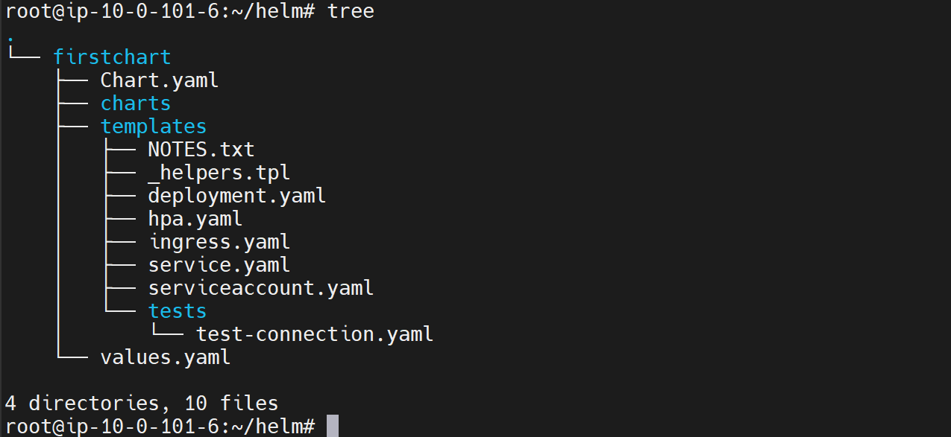

--- note - the bullion fields in YAML carry values true or false.

**If conditional statement**

--- cat values.yml

# Default values for firstchart.

# This is a YAML-formatted file.

# Declare variables to be passed into your templates.

my:

  custom:

    data: "test"

**my:**

**flag: true**

replicaCount: 1

image:

  repository: nginx

  pullPolicy: IfNotPresent

  # Overrides the image tag whose default is the chart appVersion.

  tag: ""

imagePullSecrets: []

nameOverride: ""

fullnameOverride: ""

--- deployment.yml

apiVersion: apps/v1

kind: Deployment

**{{- if .Values.my.flag}}**

**{{"output of if" | nindent 2}}**

**{{- else}}**

**{{"output of else" | nindent 2}}**

**{{- end}}**

spec:

  {{- if not .Values.autoscaling.enabled }}

  replicas: {{ .Values.replicaCount }}

  {{- end }}

  selector:

    matchLabels:

      {{- include "firstchart.selectorLabels" . | nindent 6 }}

**# Check the template of firstchart.**

--- helm template firstchart

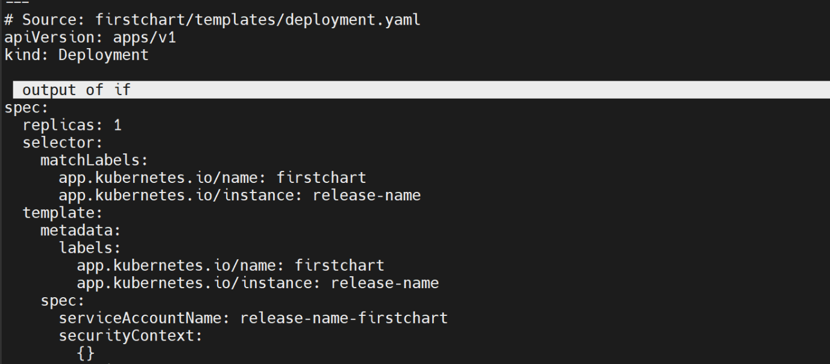

**If with and**

--- cat ingress.yml

spec:

  {{- if and .Values.ingress.className (semverCompare ">=1.18-0" .Capabilities.KubeVersion.GitVersion) }}

  ingressClassName: {{ .Values.ingress.className }}

  {{- end }}

--- **note** - all the conditions you specify here should be true.

**If with or**

--- cat ingress.yml

spec:

  {{- if or .Values.ingress.className (semverCompare ">=1.18-0" .Capabilities.KubeVersion.GitVersion) }}

  ingressClassName: {{ .Values.ingress.className }}

  {{- end }}

--- **note** – one of the conditions you specify here should be true.